About the Global Wind Summit:

The Global Wind Summit is the world’s largest wind energy gathering. Everywhere we look, wind energy is breaking new ground. New technology, new policies, and new markets worldwide are all unlocking the massive potential of wind power.
Now is the time for a global meeting of industry stakeholders to set the international agenda for a cleaner, greener future.

The Global Wind Summit takes place in Hamburg from 25-28 September 2018 and consists of two parallel events under one roof:

- The WindEurope 2018 Conference will host more than 50 conference sessions and 500 speakers and presenters, telling you all you need to know about wind energy worldwide in 2018, while
- the WindEnergy Hamburg global on- and offshore expo will gather more than 1,400 exhibitors and 35,000 visitors from over 100 countries to network, do business, and launch exciting new products.

Find out more

Here’s what our Global Ambassadors have to say:

“Decarbonising the world’s energy mix means fully exploiting the potential of renewables in the power, transport and building sectors. The Global Wind Summit is where we can set the agenda for sector-coupling and electrification to plan for a cleaner, greener world.”

Anja-Isabel Dotzenrath
Chief Executive Officer, E.ON Climate & Renewables

“The wind industry is breaking new ground in every respect today: geographically and economically, technologically and even politically. The Global Wind Summit is where all stakeholders will gather around a unified vision for the industry, worldwide, to ensure we continue breaking new ground in the future.”

Hans-Dieter Kettwig
Managing Director, Enercon

“Recent years have seen rapid evolution in the wind industry. The Global Wind Summit is about harnessing all that innovation and creating new potential for wind, worldwide. Electrification and sector-coupling are two major tools for unleashing the full potential of wind energy – onshore and offshore – and I look forward to discussing this in Hamburg in September.”

Philippe Kavafyan
Chief Executive Officer, MHI-Vestas

Find out more

About the conference

Day One: Electrification & sector-coupling

The world is moving towards an increasingly decarbonised energy supply. Europe is uniquely positioned to provide a blueprint for the rest of the world in this field. Renewables already make up 30% of the power produced in Europe. But the complete decarbonisation of Europe’s energy system means fully exploiting the potential of renewables. We need to move beyond the power sector we know today.

This means accelerating the renewables-based electrification of three sectors: transport, heating and cooling, and industrial processes. Electrification and sector-coupling have the potential to drive energy efficiency and decarbonisation economy-wide. This will make a more flexible and resilient renewables-based energy system. The WindEurope 2018 Conference at the Global Wind Summit is where you can meet and learn from the industry leaders, experts and policymakers at the forefront of this transformation.

See the programme: Day 1

Day Two: Digital wind & new technologies

R&D developments are breaking new ground in wind energy. The industry is becoming ever more sophisticated, increasingly contributing to system integration. Digitalisation is opening new ways to design, manufacture, operate and maintain wind farms.

Materials science applications that predict failures in wind turbine components at unprecedented accuracy; Big Data analyses to optimise energy yields; data ownership and data sharing; the increasing importance of cyber security in wind; system integration; lifetime extension; cost reduction.

The WindEurope 2018 Conference will keep you at the forefront of these technological breakthroughs.

See the programme: Day 2

Day Three: The wind industry in a merchant environment

In recent years, the industry has unleashed market innovations to dramatic effect. Record low strike prices are being reached in tenders. Corporate Renewable Power Purchase Agreements are transforming how major corporates source their energy. Technology cost reduction and increasing exposure to market dynamics are forcing the industry to think beyond traditional support mechanism models. We need to engage in closer dialogue with the financial sector.

This brings new opportunities, but also significant challenges: there is no one-size-fits-all model for how industry players should operate in a merchant environment. Different regions and different players require different solutions.

At the WindEurope 2018 Conference, representatives of the finance community, investors, and the broader wind supply chain will address current challenges and present new market solutions.

See the programme: Day 3

Day Four: New markets, new frontiers: the long-term outlook

New markets are emerging across Africa, Asia and Latin America. A solid pipeline of wind projects are lined up in previously quiet regions. The Global Wind Summit will bring international delegations from mature and emerging markets to exchange experience, learn from each other and sign up for new business. The series of “Invest in” sessions will give attendees an opportunity to learn about new markets and meet their key players.

There will be sessions on development in constrained and difficult-to-access regions. Lifetime extension, repowering and other end of life issues including recycling offer new market opportunities for a maturing industry.

Floating offshore wind technology is ready to be rolled out on an industrial scale and fully commercialised at utility scale projects, unlocking expanses of ocean worldwide for generating wind power.

There will be conference sessions on improving social acceptance of wind, exploring how the industry can maximise popular support for the industry, particularly in regions currently hostile to wind energy.

See the programme: Day 4

Practical Information

Getting there Hotel booking
Address:
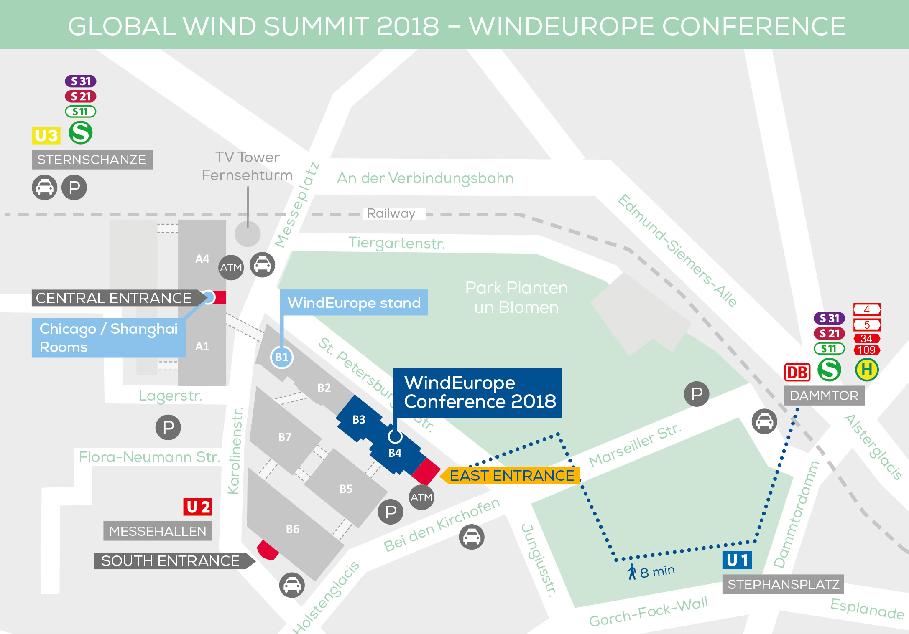
HAMBURG MESSE UND CONGRESS
Messeplatz 1
20357 Hamburg
Germany

Take the East Entrance to access the conference.
The conference takes place in halls B4 and B3.

Find out more

Social Media

Official hashtag: #GlobalWindSummit
Accounts to tag: @WindEurope @WindEuropeEvent @WindEnergyHH
Banners & Logos: Please select what you need from the “downloads” page.

Contact details

General enquiries  +32 2 213 18 05 email  Registration Team  +49 40 3569 3434 email  Conference Programme  +32 2 213 18 42 email | Exhibition sales & Sponsorship  +32 2 213 18 30 email  Press & Media  email  Media Partnerships  email

