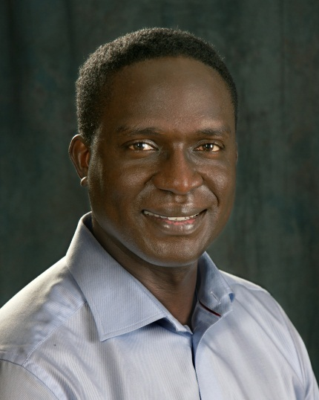 | Deo Onyango  Regional Executive, Onshore Wind  Sub-Saharan Africa  GE Renewable Energy
Deo Onyango is GE Renewable Energy’s Onshore Wind Regional Executive for Sub-Saharan Africa. With one of the broadest technology portfolios in the industry, GE Renewable Energy makes renewable power sources affordable, accessible, and reliable with innovative solutions across onshore and offshore wind, hydro, geothermal, solar and biomass.
Deo began his GE career in 2008 in GE Capital based in London. In 2010 he joined GE Africa as Regional Commercial Growth Leader for East Africa reporting to Jay Ireland, President and CEO, GE Africa.
Prior to GE, Deo was Vice President in Citi Private Bank's Financial Sponsors group based in London. He joined Citi in 2001 through the bank’s financial analyst program.
He holds a Masters in Finance (Msc) from London Business School, a Graduate Diploma in Investment Management from London School of Economics and an undergraduate degree in commerce and economics from the University of Nairobi.
Deo currently serves on the Boards of the American Chamber of Commerce Kenya, Junior Achievement Kenya and Shining Hope for Communities (SHOFCO). He and his wife have two children.

