WindEurope Offshore 2019
Copenhagen 26–28 November 2019

About the WindEurope Offshore 2019:

WindEurope Offshore 2019: Our energy, our future
How offshore wind will help Europe go carbon neutral
This November, 9,000 wind industry professionals will gather in Copenhagen for Europe’s premier offshore wind event. Europe needs unprecedented amounts of offshore wind to decarbonise its energy mix – and Copenhagen is where the road to carbon-neutrality begins.
Join 250 top-level speakers who will bring you the latest insights and trends. Be at the networking events plenty of opportunities to connect and do business. And enjoy over 400 exhibitors, a 200m Safety Skills & Training Zone, a Global Markets Theatre and the brand new Innovation park, where you can meet start-ups new to the field.

Here’s what our Event Ambassadors have to say:

“Offshore wind is now due to play a central role in the decarbonisation of Europe. Policymakers, corporates and citizens as a whole shall work together to unlock its full potential. WindEurope Copenhagen comes at the right time to shape the cornerstone to achieve net zero emissions by 2050.”
Philippe Kavafyan
Chief Executive Officer, MHI Vestas

“A Europe that runs entirely on green energy will ensure sustainable growth for all Europeans. It is a giant task, but we have the technologies and solutions at hand. Offshore wind energy is needed at a large scale and the industry is ready to deliver our core part of the European Green Deal.”
Martin Neubert
CEO Offshore, Ørsted

“Shell is making progress in the energy transition: growing our renewable power projects, signing PPAs and supplying lower-carbon solutions to our customers. Our collaborative work in offshore wind, including innovative floating-wind technologies, can help deliver clean electricity at the sort of scale that Europe will need to become climate-neutral by 2050. ”
Dorine Bosman
Vice President – Offshore Wind, Shell

“The ambition of Van Oord is to act as an initiator for accelerating the energy transition while also creating societal value. We are fully committed to enhancing the energy transition by enabling the large scale roll out of offshore wind. Sector-wide collaboration and innovations are key in making this transition a success.”
Pieter van Oord
Chief Executive Officer, Van Oord

Find out more

Practical Information
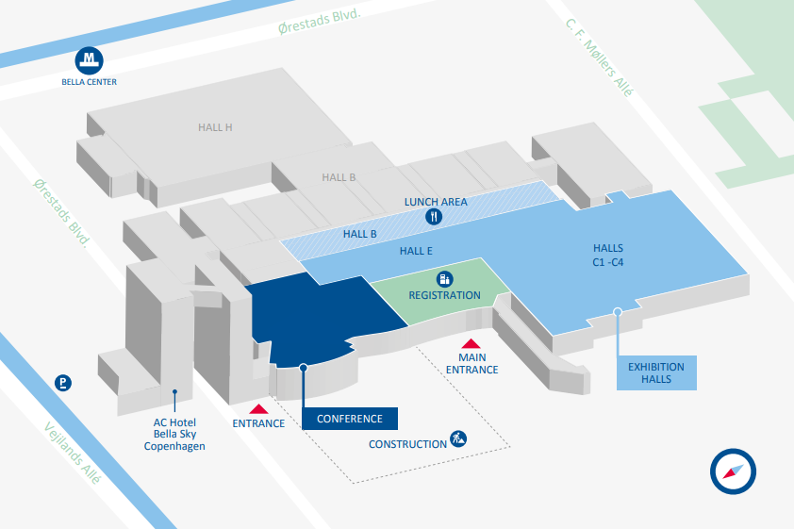
Getting there Accommodation
Address:
BELLA CENTER
Center Boulevard 5
DK-2300 Copenhagen S
Denmark
Find out more

Social Media

Official hashtag: #Offshore2019
Accounts to tag: @WindEurope @WindEuropeEvent
Banners & Logos: Please select what you need from the “downloads” page.

Contact details

General enquiries  +32 2 213 18 05 email  Registration Team  +32 2 213 1805 email  Conference Programme  +32 2 213 18 42 email | Exhibition sales & Sponsorship  +32 2 213 18 30 email  Press & Media  email  Media Partnerships  email

