WindEurope 2019 Conference & Exhibition
Bilbao 2-4 April 2019

About the WindEurope 2019 Conference & Exhibition:

This April, more than 7,000 delegates will gather in Bilbao for Europe’s leading wind energy event.
They will join nearly 300 conference speakers – including the Spanish and Portuguese Ministers for Energy – to learn, network and shape the vision for Europe’s future.
The WindEurope 2019 Conference & Exhibition takes place in advance of the European elections, with wind energy now set to become the EU’s largest power source well before 2030. This is the perfect opportunity to showcase the benefits wind energy brings to people and to shape a united vision for a cleaner, greener Europe.
Why? Because Europe stands at a crossroads. The economic and technological realities of our lives are transforming, and people know the times are changing. It’s clear that the world of tomorrow will not be the world we live in today. The decisions we make now will shape people’s futures. With the current discussions on climate change dramatically raising citizens’ awareness, we need urgent action to decarbonise our energy mix.
And with the European elections approaching in May 2019, the wind industry has a great opportunity to engage with people and guide them to make the right choices. So let’s ask ourselves a very simple question:

What kind of world do people want?

There are some clear, obvious answers: people want a world of prosperity and jobs. Investments and growth. Clean and affordable energy. People want a world where their local, regional and national communities can thrive.
• Wind energy can help deliver on all of these ambitions.
• Wind is already revitalising regions that have suffered from the pollution and unemployment caused by brown energy.
• Wind already provides more than 300,000 jobs in Europe, transforming deprived regions and improving the lives of people on local, regional and national levels.
• Wind is already on course to be the EU’s largest power source before 2030 – overtaking coal, nuclear and gas.
• This is all because wind energy is investing in people, delivering for communities. Wind energy is delivering power to people.
But we can do so much more. With the right policies and vision in place, wind can breathe life into the sort of future people want. And that’s why, in advance of the European elections, the wind industry will be gathering in Spain next April.

Spain: a shining example of what wind can do for people

Spain is a great example of how the wind industry revitalise and empower communities.
National impact: Spain is a leading European wind manufacturing hub, accounting for 22,000 jobs. Spain’s influence was key in obtaining a higher EU-wide target for renewable energy for 2030 of 32%. Spain’s first offshore wind turbine was installed in June 2018 and the Canary Islands recently stated their intention to build up to 300 MW of offshore wind by 2025, including floating offshore wind. This national ambition is an outgrowth of the regional impact of wind energy.
Regional impact: The Basque Country made a conscious decision to invest in the wind industry and is reaping the benefits in investment, jobs and growth. The region has become a significant industrial cluster for wind energy, producing and exporting cutting-edge equipment and technology to the rest of Spain and Europe. The Basque Country has one of the world’s highest regional concentrations of the wind energy supply chain and proves that a region without optimal wind resources can still benefit massively from the growth of the industry.
Local impact: Bilbao is a great example of how the concentration of leading global wind energy players contributes directly to a local economy. From the Port of Bilbao and the Research Centre to market leaders like Siemens Gamesa Renewable Energy and Iberdrola who have chosen base their global HQ there, Bilbao is demonstrates how wind energy brings real local economic value and jobs, helping to build local acceptance for wind energy.
All this makes Bilbao a logical choice to host the annual European wind industry get-together in 2019. Spain is a clear example of how, with the right policy and vision in place, wind energy can deliver power to people. The European elections will be just around the corner of the event, and will have a major impact on European energy policy for the following five years.

Join us in Bilbao, and play your part in Delivering Power to People.

Here’s what our Event Ambassadors have to say:

“Wind energy is a key enabler of the energy transition, providing reliable, competitive and sustainable electricity. At the same time, it is also fostering the creation of highly-skilled jobs and revitalising local supply chains. Iberdrola is fully committed to continue powering a better future through wind.”
Ignacio Galán,
Chairman Chief and Executive Officer, Iberdrola

“At Siemens Gamesa, we are determined to play a leading role in addressing our planet’s energy needs by providing people and communities worldwide with clean, affordable and reliable renewable power. At the same time, we have a deep commitment to improving the communities in which we operate by creating jobs and growth, protecting our natural environment, and improving people’s quality of life.”
Markus Tacke
Chief Executive Officer, Siemens Gamesa

“As the largest global independent manufacturer of wind turbine blades, TPI Composites is helping to decarbonise the world’s energy mix in a cost effective manner. We’re also impacting the people we employ and the communities in “
Steve Lockard
Chief Executive Officer, TPI Composites

Find out more

Practical Information
Getting there Accommodation
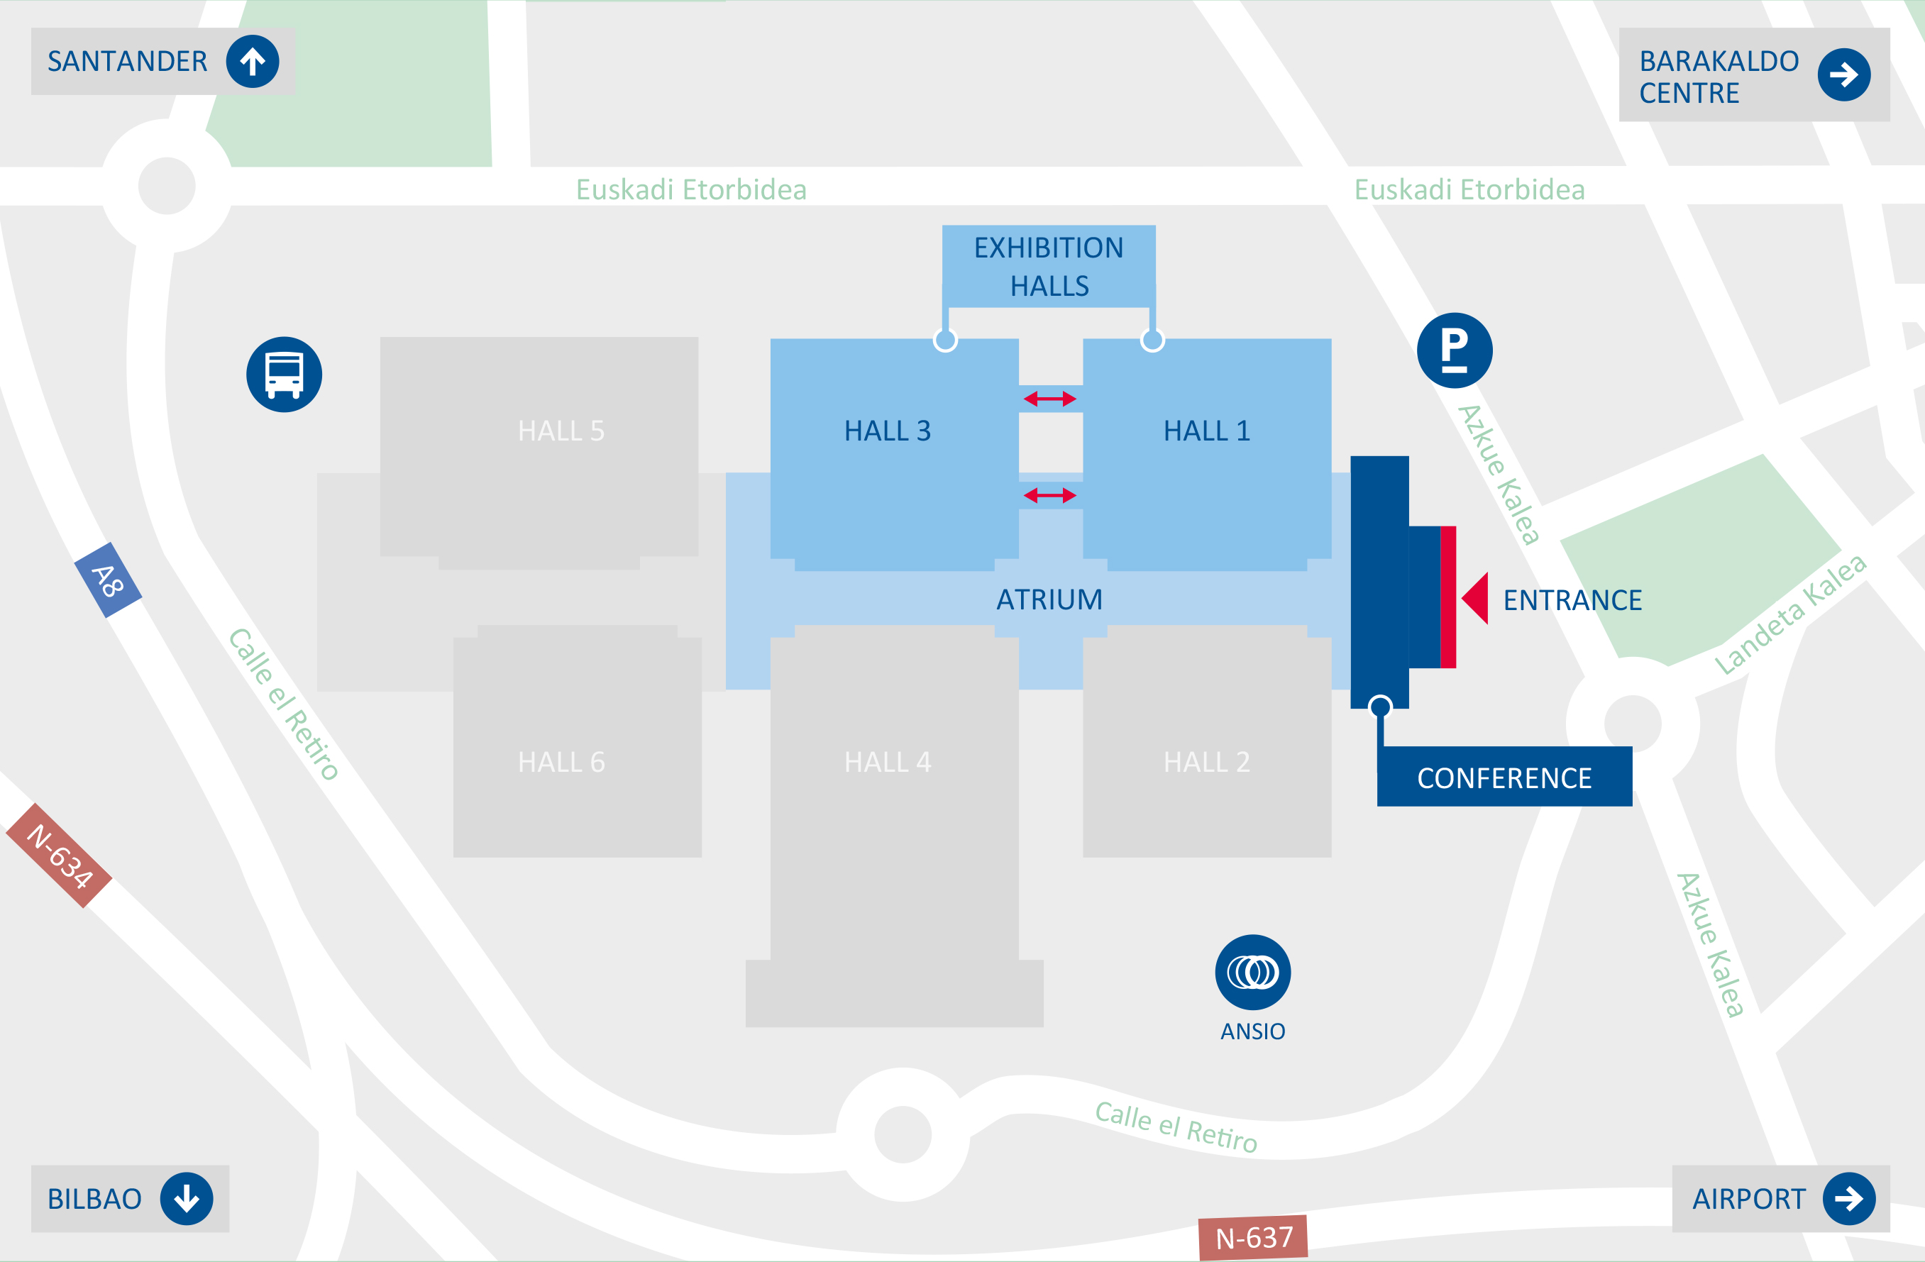
Address:
BEC – Bilbao Exhibition Centre
Azkue Kalea, 1, – North Entrance
48902 Barakaldo
Bizkaia, Spain

Find out more

Social Media

Official hashtag: #WindEurope2019
Accounts to tag: @WindEurope @WindEuropeEvent
Banners & Logos: Please select what you need from the “downloads” page.

Contact details

General enquiries  +32 2 213 18 05 email  Registration Team  +32 2 213 1805 email  Conference Programme  +32 2 213 18 42 email | Exhibition sales & Sponsorship  +32 2 213 18 30 email  Press & Media  email  Media Partnerships  email

